Revision Date |  |  | LPG  Unload Railcar | Annual Certification
Original Date: April 2007 |  |  | LPG  Unload Railcar | Date
 |  |  | LPG  Unload Railcar |  |  | 2007
 |  | 2007 | LPG  Unload Railcar |  |  | 2008
 |  | 2008 | LPG  Unload Railcar |  |  | 2009
 |  | 2009 | LPG  Unload Railcar |  |  | 2010
 |  | 2010 | LPG  Unload Railcar |  |  | 2011
 |  | 2011 | LPG  Unload Railcar |  |  | 2012

CAUTION: Liquefied Petroleum Gases are under pressure and are highly flammable. Tighten all connections to prevent leaks. Take care to avoid sources of ignition, such as running vehicles, welding machines, or static discharge. LPG can produce frostbite on exposed skin. Wear hand protection

Note: Before proceeding with the procedure, proper lineups to / from the tanks and rail racks must be made. The appropriate drawings should be reviewed (referenced at end of procedure) by the Pumpers to ensure that proper lineups have been made to/from the appropriate tank and the rail rack.

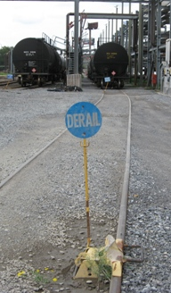
Date Time Initials

- Inspect and prepare railcar.

  - Inspect the railcar for damage.
  - Set the caution signs and derails on the track, just west of the #1 loading spot and just east of the #6 spot.
  - Ensure brakes are set and properly place chocks.
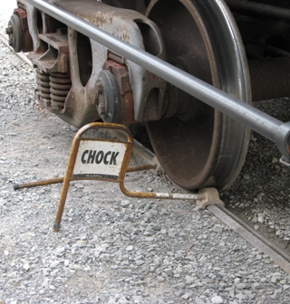
  - Verify that the carseal is in place. (applies to inbound Railcar of purchased material)
    - If the seal is missing, broken or has been tampered with, the car must be sampled prior to unloading.
  - Break carseal, open the dome lid and obtain an outage gauge and temperature on the railcar.
- Sample Railcar (if required) per procedure LPG Sample Railcar

- Connect Railcar for Unloading
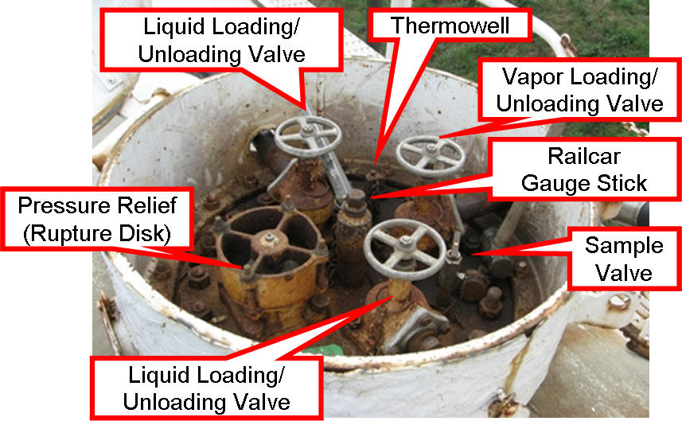
  - Verify that the Railcar loading/unloading liquid and vapor connection valves are tightly closed.
  - Using a pipe wrench, carefully and slowly remove plugs from the Railcar loading/unloading connections.
    - Watch for any pressure as each plug is loosened that might indicate the valve is leaking or some other problem exists.

NOTE: If you suspect any Valve may be leaking, do not remove plug. Re-tighten plug and contact Tank Farm Superintendent/Shift Superintendent immediately.

  - Install fittings on one or both liquid connections (depending on the flow required) and one vapor connection.
  - Connect the vapor and liquid loading arms to the railcar.
  - Using the Vapor Loading arm, check the pressure on the Railcar as follows:
    - Ensure product vapor valves below the pressure are securely closed.
    - Open the vapor connection valve on the Railcar and check for leaks.
    - Open the upper valve on the vapor loading arm.
    - Note the pressure on the pressure gauge on the vapor loading arm.
NOTE: If the noted pressure does not correspond to the expected pressure for the product to be unloaded, the car will need to be sampled and tested prior to unloading to confirm the contents.

- If Sampled – Check Results in LIMS and ensure product meets specifications prior to proceeding.

- Line up the receiving tank.
  - Get an opening gauge and temperature on the receiving tank.
  - Ensure that the liquid line at the receiving tank is open.
  - Ensure that the vapor line at the receiving tank is open.
  - Double-check all valve alignments before leaving the area.

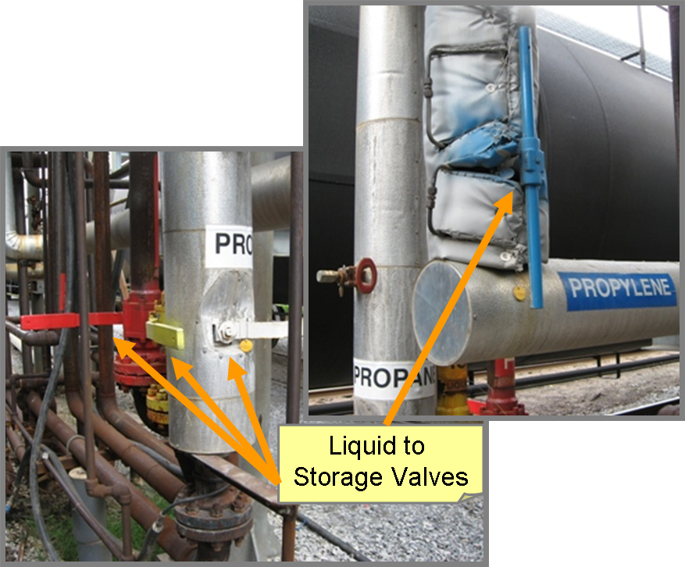
- Open the liquid and vapor unloading lines at the LPG rail rack.
  - Return to the LPG rack and open the valve on the appropriate product liquid line (below the loading platform at ground level).
  - Atop the rack, check the bleeder lines to make sure the valves are closed.
  - Open the vapor unloading valve on the appropriate product line below the pressure gauge on the unloading platform.
  - Slowly open the liquid valve on each liquid loading arm to be used.
  - When the liquid loading arms are pressured up, slowly open the liquid valves on the railcar. Tighten any connections that leak.

- Line up compressors.
  - Select a compressor for unloading the railcar. Open the valve on the appropriate product vapor line coming from the receiving tank.
  - Open the valve on the appropriate product vapor line going to the railcar rack. Make sure the valve between the tees on the vapor line is closed.
  - Place the handle on the compressor four-way valve in the vertical position. This lines the compressor up to pull vapor from the receiving tank and discharges it to the railcar.
  - Open the drains on the compressor liquid traps to the flare long enough to make sure that all liquid is off.

- Unload the railcar.
  - Turn on the compressor. Watch the inlet and outlet pressures to make sure they stabilize. This is to ensure that the vapor line is not blocked in at some point.
  - Watch the unloading arm sight glasses. Make sure there is full liquid flow. If not, double-check your valve alignment to make sure the lineup is correct.
  - When the railcar is empty, close the liquid valve under the rack.

- Pull vapors on the railcar.
  - Turn the compressor off, then lower the handle on the compressor valve to the horizontal position. This reverses the suction and discharge on the compressor.
  - Restart the compressor.
  - You may now close the liquid valves on the railcar. Open the bleeder to the flare line for each arm that is used to release the pressure from the liquid line.
  - Close the valve on each liquid loading arm used.
  - Run the compressor until railcar pressure falls to 5 psig or lower, then turn the compressor off. Close the valves on the compressor inlet and outlet.
  - Return the compressor valve handle to the vertical position.
  - Close the product vapor valves on the platform and the vapor valve on the railcar.

- Unhook railcar.
  - Open the bleeder on the vapor arm to relieve pressure to the flare.
  - When pressure is bled off of all three arms, close the bleeders.
  - Close the valve on the vapor loading arm.
  - Slowly loosen the collars on the loading arms, then disconnect them.
  - Remove the liquid and vapor fittings from the railcar.
  - Replace the plugs in the liquid and vapor connections (wrench tightened).
  - Lower the dome lid and replace the pin.
  - If no more railcars are unloading or loading, remove the chocks and loading signs from the track.

- Close out tank.
  - Get a gauge and temperature on the receiving tank.
  - Record the transfer on the pumpers' unloading sheet.

PROCEDURE INFORMATION

PURPOSE
This procedure details the steps necessary to unload an LPG railcar.

PREREQUISITES
Department of Transportation preloading or unloading requirements must be met. DOT requirements are posted at the loading rack.

RESPONSIBILITY
It is the responsibility of the Pumper Number 3 to carry out this procedure in a safe and timely manner.

MATERIALS AND EQUIPMENT
24" pipe wrench, brass hammer, wheel chocks, caution signs, Department of Transportation liquefied petroleum gas load placards.

SAFETY
Special or Unique Hazards: . Make sure that all connections are tight and do not leak. Do not leave the pumper’s truck running. Exercise caution while on the elevated loading rack. Never drop tools from the rack. Do not leave the railcar unattended while it is loading or unloading.

Engineering Controls: N / A

Administrative Controls: This procedure is a control to ensure that the LPG is unloaded safely and efficiently.

Personal Protective Equipment (PPE): Normal Tank Farm personal protective equipment must be worn at all times. This includes hard hats, fire retardant clothing and safety glasses. Additional protective equipment may be required per permit requirements.

SAFETY SYSTEMS
Shutdowns: N/A

Other Safety: N/A.

QUALITY AND INVENTORY
Inventory: Sufficient room must be available in the tank to unload the railcar. Do not overfill the tank and lift the relief valves.

Quality: The product must meet the refinery specifications requested.

OPERATING LIMITS:
Description | Limits | Consequences of Deviation | Corrective and Avoidance Steps
N / A

CHEMICAL SAFETY:
General information is provided here. Additional information is available from the MSDS sheet for the specific material in question.
Chemical Name | Properties | Hazards | Actions if Exposed
Hydrocarbon Liquids  LPG:  Propane  Propylene  Butane  Butylene  Isobutane | Flammable materials  LPG is a vapor at atmospheric temperature and pressure | Fumes or mists can be irritating to the skin eyes and respiratory tract and can cause drowsiness, headache, and nausea. Overexposure to vapors can lead to unconsciousness or convulsions, bronchopneumonia, and even brief inhalations of high concentrations can cause fatal pulmonary edema.  LPG Liquid causes freeze burns upon contact to skin or eyes.  Hydrocarbon vapors can burn or explode on contact with a source of ignition in the presence of air or oxygen. | In case of skin contact with liquid LPG immediately wash with tepid water. If freezing burns have occurred, apply bulky, dry, sterile bandage and get medical attention.  In case of eye contact, immediately flush eyes with water for 15 minutes including under the eyelids, and see a physician.  If swallowed see a physician, do not induce vomiting.  If inhaled, remove to fresh air. If not breathing, give artificial respiration. See a physician

Drawing No. (Prefix 524 - B) | Description of Drawing:
503, 504 | MERCAPTAN SYSTEM
502, 503, 504, 524, 525, 526, 527 | LOADING RAILCARS FROM ALL PROPANE TANKS
505 | VAPOR LINES ON ALL PROPANE TANKS
505, 524, 525, 526, 527A | VAPOR LINE TO RAILCAR RACKS
507, 508, 517, 518, 524, 525, 526, 527 | ISOBUTANE LIQUID TO / FROM 805,806 TKS & SPHERES TO / FROM RAILCAR RACKS AND TRUCK RACK
507, 510, 519, 524, 525, 526, 527A | ISOBUTANE VAPORS TO / FROM 805,806 TKS & SPHERES TO / FROM COMPRESSORS AT RAILCAR RACKS AND TO TRUCK RACK
509, 524, 525, 526, 527 | POLYPROPYLENE LIQUID TO / FROM 1807,8,9 TKS TO / FROM RAILCAR RACKS
510, 524, 525, 526, 527A | POLYPROPYLENE VAPORS TO / FROM 1807,8,9 TKS TO / FROM COMPRESSORS AT RAILCAR RACKS
513, 514, 512, 510, 509, 524, 525, 526, 527 | NORMAL BUTANE LIQUID LINE TO / FROM VERTICAL BULLETS TO / FROM LPG R/R RACKS
515, 515A, 510, 524, 525, 526, 527A | NORMAL BUTANE VAPOR LINE (INSULATED) TO / FROM VERTICAL BULLETS TO / FROM COMPRESSORS AT LPG R/R RACKS AND TRUCK LOADING RACK
518, 517, 509 | TRANSFER 116,117 TKS TO LPG R/R RACKS THRU 6” POLYPROPYLENE LIQUID LINE
519, 510 | 4” VAPOR LINE FROM 116, 117 TKS TO LPG R/R RACKS

Drawing No. (Prefix 1024-D) | Description of P&I Drawing:
306, 316 | RAIL ROAD LOADING COMPRESSORS

